**The strange seahorse tail**

*The unique mechanics of square – not circular – limbs*

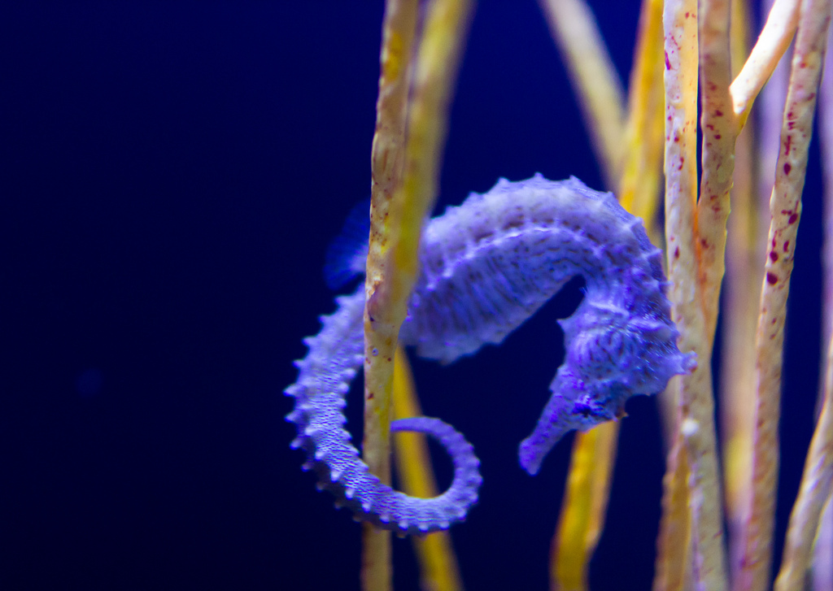By Diana LaScala-Gruenewald

At first glance, the animal kingdom has no shortage of tails. From crocodiles to platypuses, squirrels to pigs and fish to boa constrictors, the shapes, sizes and textures are diverse. But whether flat, flexible, paddle-like, scaly, bare, mighty, curly or fluffy, all tails have one thing in common: they are roughly circular in cross-section. Of all the tails in all the world, there’s just one that differs. And it belongs to the seahorse.

Most people already think that seahorses are fascinating creatures. Their wild colors, upright, single-fin swimming style, fanciful similarity to real horses and the fact that [male seahorses get pregnant](https://www.youtube.com/watch?v=I7zzgvteu7Q) all contribute to their mystique. But if you take a close look at their rear ends, you might notice another under-appreciated feature. Seahorse tails are curly and muscular, and can wrap tightly around sea grasses, mangrove roots and coral reefs. And, also, they’re square.

Like a cat or dog’s tail – or your tailbone, for that matter – the seahorse tail is formed by a set of vertebrae. But in seahorses, each vertebra is surrounded by four, interlocking L-shaped plates (Figure 1). These plates give the tail its unique square cross-section, instead of the circular one characteristic of other animals.

**An engineering approach to a biological question**

So what are the advantages of having a square tail? [Michael Porter](http://www.clemson.edu/cecas/departments/me/people/faculty/porter.html), an Assistant Professor of Mechanical Engineering at Clemson University, wanted to know exactly that. To find out, he teamed up with engineers from Oregon State University and the University of California, San Diego. The results of their study were [published in Science](http://science.sciencemag.org/content/349/6243/aaa6683) last year*.

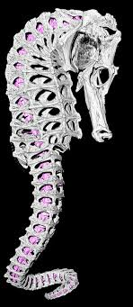To determine the advantages of a square tail, Porter’s team decided to examine two categories of tail functions: movement and protection. Seahorses don’t use their tails to swim; instead, they use them to grasp objects in their environment while they camouflage to hide from predators, and hunt for prey. Flexibility is a key feature that enables these behaviors. In addition, seahorse tails must be resilient – they have to recover their shape after impact. Many creatures prey on seahorses, including fish and sea birds. When these predators decide to take a bite, some structural resilience comes in handy.

Before they could begin experiments, Porter and his colleagues faced a problem. They needed to compare square tails to circular ones, but no circular-tailed seahorses exist in nature. So instead, the engineers created one! They used a special imaging technique called microcomputed tomography to obtain high-resolution, three-dimensional pictures of seahorse tails. Then, they designed a hypothetical tail that was identical, but circular in cross-section. Finally, Porter and his colleagues [3D-printed](https://www.youtube.com/watch?v=Vx0Z6LplaMU) copies of both tails for experimentation.

Figure 1. A computer model of a seahorse skeleton, highlighting the four interlocking, L-shaped plates that surround each vertebra (purple). Photo Credit – Oregon State University.

The circular tail curled up just as well as the square one. But it when it came to twisting, the square tail had some interesting features. The circular tail could twist almost twice as far, and didn’t relax when released. The square tail, on the other hand, had limited twisting abilities and naturally returned to a straight alignment when released. Based on these data, Porter and his colleagues hypothesized that the square tail prevented seahorses from hurting themselves by twisting too far, and saved the animal energy by naturally returning to a neutral position.

In addition, the square tail was more resilient to a simulated bite from a predator. The researchers gave each tail a whack with a rubber mallet, and observed that the square model tail returned to its original shape while the circular one remained partially crushed and misaligned. And when squeezed, the square tail did not change shape but the circular one did. Based on these data, Porter’s team concluded that a square tail might prevent vertebral fracture due to impact or crushing. A square-tailed seahorse would have a better chance of survival after a bite from a predator than a circular-tailed one.

**Taking the long view**

So what does all this mean for seahorses? [Researchers believe](http://onlinelibrary.wiley.com/doi/10.1111/joa.12181/abstract) that ancient seahorses had stiff, square skeletons that served as protection against predators. Then, they evolved to be more flexible, facilitating hunting and camouflage. But modern seahorses kept the old square skeleton structure, and Porter proved that it’s not just a fashion statement: it allows seahorses to twist and turn without hurting themselves, and provides a suit of armor against bird and fish predators.

*PDF provided upon request.

References:

<http://science.sciencemag.org/content/349/6243/aaa6683.full>